#
# I wanted to geit iLO ip addres via cli utility on Gen10 server.
# But it was unsuccessful.
#
# I find that, for working hponcfg need CHIF driver hpilo.
# But where is it and how it could be received… I couldn’t find.
#

[root@ds-tms-kvm01p ~]# dmidecode -t system
# dmidecode 2.12-dmifs
SMBIOS 3.1 present.
# SMBIOS implementations newer than version 2.8 are not
# fully supported by this version of dmidecode.

Handle 0x008D, DMI type 1, 27 bytes
System Information
Manufacturer: HPE
Product Name: ProLiant DL360 Gen10
Version: Not Specified
Serial Number: CZJ812004C
UUID: 39373638-3935-5A43-4A38-313230303443
Wake-up Type: Power Switch
SKU Number: 867959-B21
Family: ProLiant

Handle 0x00AE, DMI type 32, 11 bytes
System Boot Information
Status: No errors detected

[root@ds-tms-kvm01p ~]#

[root@ds-tms-kvm01p ~]# cat > /etc/yum.repos.d/nexus-tcs-hp.repo
[nexus-tcs-hp]
name=Nexus - HPE Software Delivery Repository for spp
baseurl=http://repo-linux.tcsbank.ru/repository/hp/repo/spp-gen10/rhel/$releasever/$basearch/current
enabled=1
gpgcheck=0
repo_gpgcheck=0
skip_if_unavailable=true
proxy=_none_
[root@ds-tms-kvm01p ~]#

[root@ds-tms-kvm01p ~]# yum install hponcfg
...
Installed:
hponcfg.x86_64 0:5.4.0-0
...

[root@ds-tms-kvm01p ~]# rpm -ql hponcfg
/sbin/hponcfg
/usr/lib64/libhponcfg64.so
/usr/share/doc/hponcfg
/usr/share/doc/hponcfg/readme.txt
/usr/share/smartupdate/hponcfg/component.xml
[root@ds-tms-kvm01p ~]#

[root@ds-tms-kvm01p ~]# hponcfg
HP Lights-Out Online Configuration utility
Version 5.4.0 Date 8/6/2018 (c) 2005,2018 Hewlett Packard Enterprise Development LP

ERROR: CpqCiCreateFunc() 0 time failed.
Driver Error Code:(1,1h).
Driver Error Message: CPQCIDRV driver is not loaded.

ERROR: CpqCiCreateFunc() 1 time failed.
Driver Error Code:(1,1h).
Driver Error Message: CPQCIDRV driver is not loaded.
ERROR: A general system error occurred while detecting Management Processor.
ACTION REQUIRED: Check if iLO and iLO driver are up and running.
[root@ds-tms-kvm01p ~]#

https://community.hpe.com/t5/ProLiant-Servers-ML-DL-SL/DL-gen10-conrep-error/td-p/7011436#.XRXYP4gzYwE

https://community.hpe.com/t5/ProLiant-Servers-ML-DL-SL/Driver-Error-Message-CPQCIDRV-driver-is-not-loaded/td-p/6968577#.XRXVwYgzYwE

https://support.hpe.com/hpsc/doc/public/display?docId=a00018323en_us
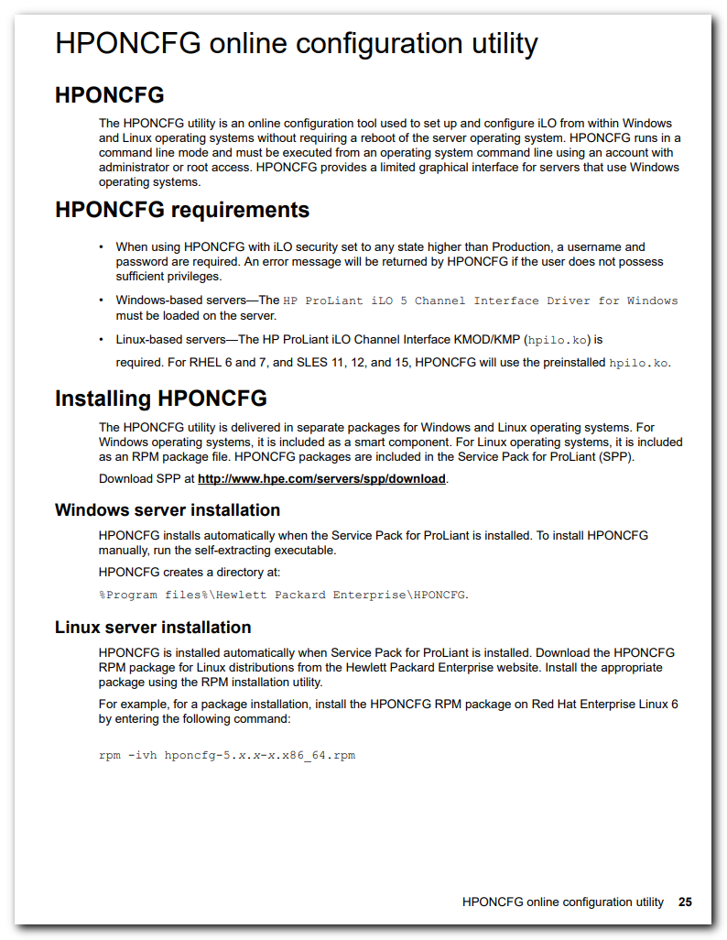

https://downloads.linux.hpe.com/SDR/project/mcp/
